SUGERENCIAS: BARES PARA TAPEAR EN SEVILLA
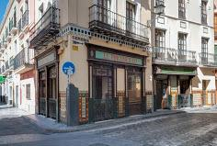
Zona centro
El Rinconcillo. Calle Gerona, 40
Espinacas (spinach with spices and chickpeas)
Pringá (like brisket meat of pork)
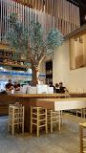
Perro Viejo. Calle Arguijo, 3
Patatas Bravas(spicy French fries)
Cheese
Pasta
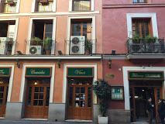
Los Coloniales. Plaza de Cristo de Burgos, 19
Calle Fernández y González, 36
Solomillo al whiskey (pork cooked with garlic and whiskey), a la castellana (onion and mushrooms) o al Roquefort (blue cheese/cream sauce)
Pollo con salsa de almendras o delicia de pollo
Zanahorias aliñadas (coldpickledcarrots)
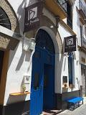
Brunilda. Calle Galera, 5

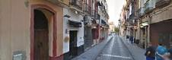
Ovejas Negras. Calle Hernando Colón, 8

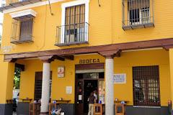
Bar Las Columnas. Calle Mateos Gago con Calle Rodrigo Caro
Montadito de pringá (small sándwich of pork brisket)
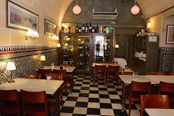
Tortilla (potato and egg omelet)

BAR GIRLADA: c/Mateos Gagos
Flamenquín (roll of pork filled with ham and cheese and then fried)
Ensaladilla (potato salad with tuna)

Patio San Eloy. Calle San Eloy
Montaditos (small sandwiches)
Tarta vegetal (multi-layered sandwich with mayonaise, lettuce, tuna)
Aceitunas
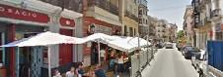
Mesón El Serranito. Calle Antonia Díaz, 11
Serranito(a bocadillo: pork or chicken meat, ham, fried Italian green pepper)
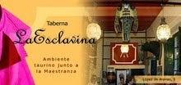
Taberna La Esclavina. Calle López de Arenas, 5, 41001 Sevilla

Montaditos (small sandwiches)

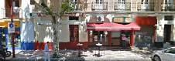
Pepe Hillo . Calle Adriano, 24

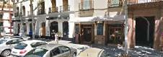
El Baratillo. Calle Adriano, 22

ZONA ALAMEDA-ZONA CENTRO
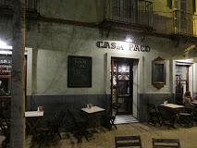
Casa Paco. Plaza Alameda de Hércules, 23

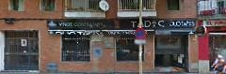
Duo Tapas. Calle Calatrava, 10

El aljibe. Plaza Alameda de Hércules, 76

Solito Posto. Plaza Alameda de Hércules, 16
Resturante Italiano
El Eslava. Calle Eslava, 3
La azotea. Calle Jesús del Poder, 31

ZONA TRIANA
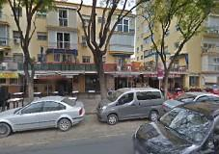
SALOMÓN REY DE LOS PINCHITOS: c/López de Gomara
Pinchito (seasoned pork on a skewer)
Adobo (marinated fish, fried)
Berenjenas Fritas con miel (fried eggplant with honey)
Papas Bravas (fried potatoes with a spicy red sauce)

LAS GOLONDRINAS: Pagés del Corro, 76 Y Calle Antillano Campos, 26
Champiñones (mushrooms with garlic and parsley)
Solomillo plancha (pork fillet)
Zanahorias aliñadas (cold pickled carrots)
Caballito de jamón
Pisto (vegetable stew)
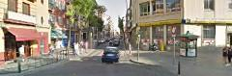
Blanca Paloma. Calle Pagés del Corro, 86

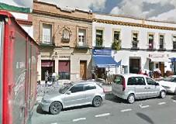
El Alboroque. Pagés del Corro, 107

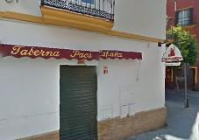
Paco España. Calle Alfarería con Calle Antillano Campos
Croquetas
Ensaladilla
Montaditos
TAPAS BUENAS EN GENERAL
Gambas al ajillo (shrimp with garlic, cayenne and olive oil
Adobo (marinated fish, fried)
Choco frito (fried cuttlefish, like calamares)
Croquetas (fried balls filled with ham, meat, fish…depending)
Gazpacho (cold tomato soup)
Salmorejo (thick versión of gazpacho with more garlic, often used as a sauce)
Carrrillada (stewed meat)
Flamenquín (roll of pork filled with ham and cheese and then fried)
San Jacobo (slice of ham and cheese fried)
Pisto (vegetable stew, often served with an egg)
Patatasali-oli (potato salad with a garlic mayonaise)
Papas Bravas (fried potatoes with a spicy tomato sauce)
Papas Aliñadas (cold potatoes with onion, tuna, oil and vinegar)
Lagrimitas de pollo (marinated fried chicken pieces like strips)
Serranito

